SOP For Creating Dashboard
*Prerequisite*
- Product Team should be part of the relevant CMDB Security groups. Look for the group here (Enterprise SNOW) - Group / User Search and replace the name of the group highlighted below as per your CMDB ID.

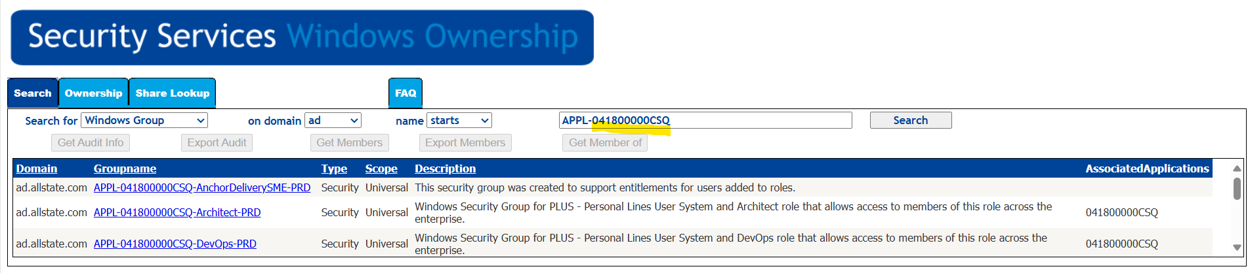

Note: If the CDMB security groups are not created for your product, you can request to update the CI in Enterprise SNOW. Click here and update the core attribute Security Group Required value to ‘Yes’

*Steps For Creating Dashboard*

- Navigate to the Datadog URL (Enterprise) - QuickQuote Host Observability | Datadog

- Click on the Configure (Top right on the dashboard having settings icon) and hit Clone dashboard.
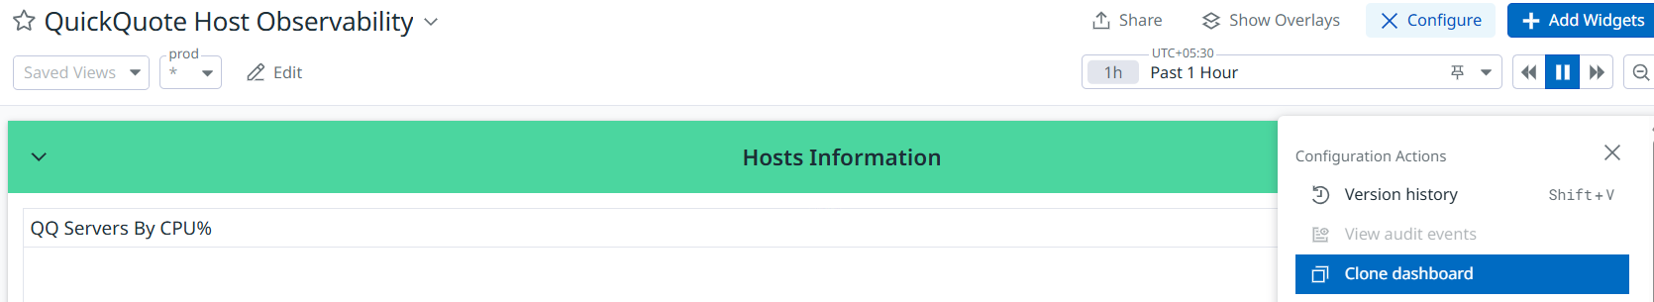

- Clone Dashboard screen will pop-up and rename the Dashboard name and Description according to your Product/App and click on Clone button.
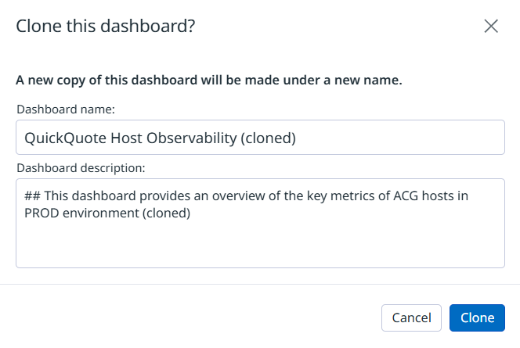
- Click on each widget to edit the query parameters/filters respective to your product/app (as given below).

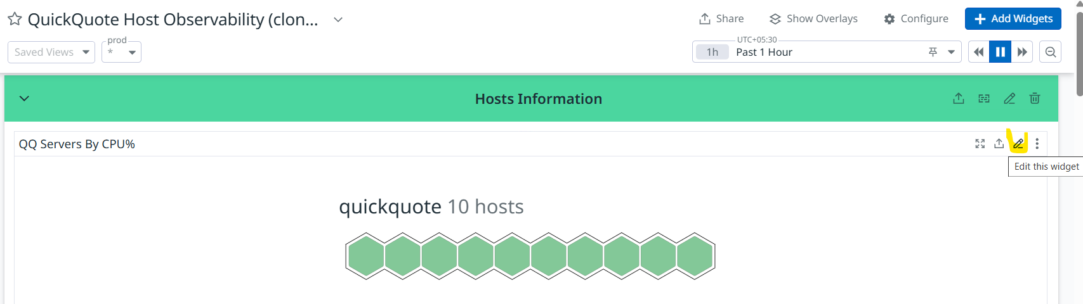

- Update the query filter and graph title as per your application and click on Save.
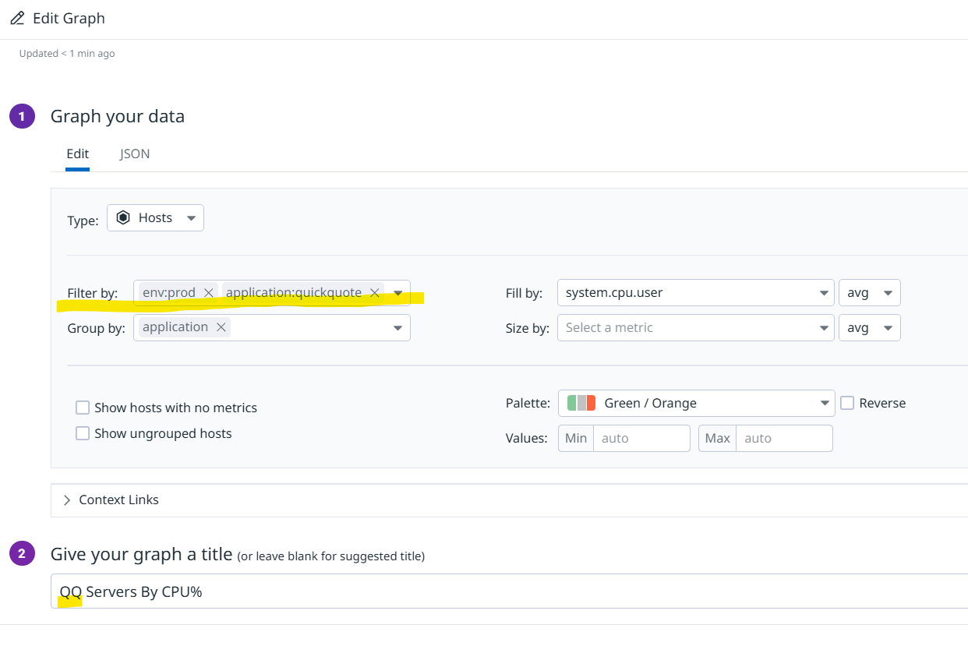

- Edit Monitor Summary – Current Status widget and update barometerit tag of your product/app (make sure you’re adding this value in upper case) highlighted in the below snap and click Save.

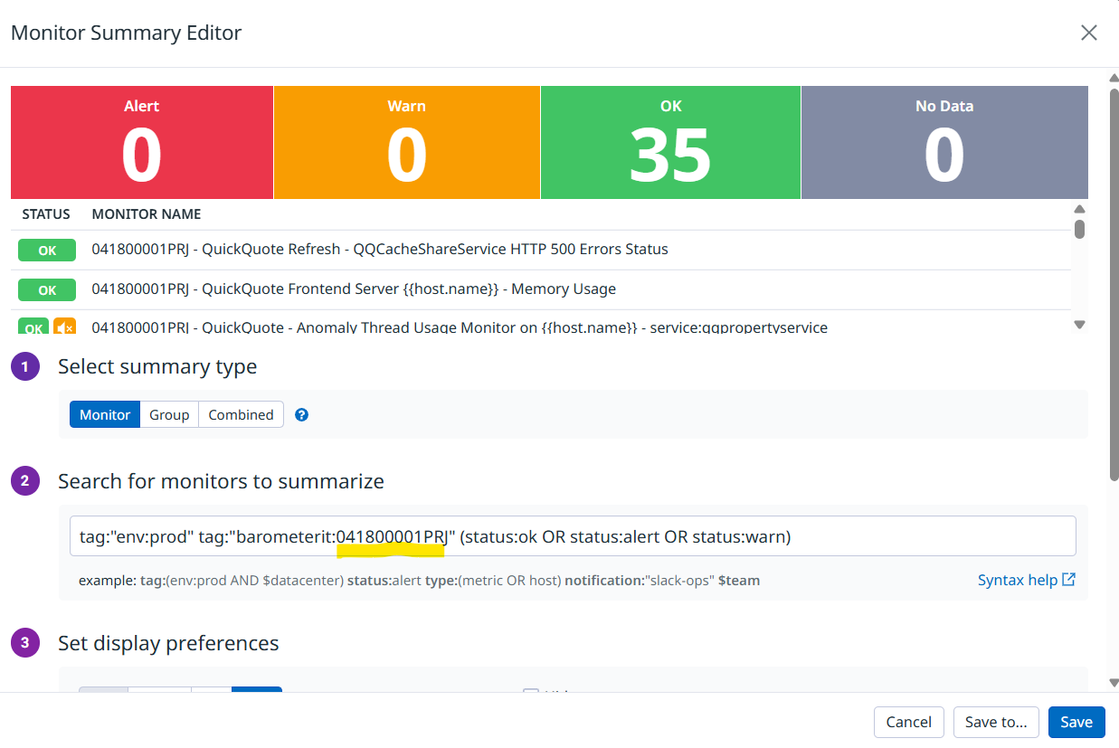

- Edit CPU, Memory & Disk usage graphs and replace the highlighted value as per your application and click on Save.
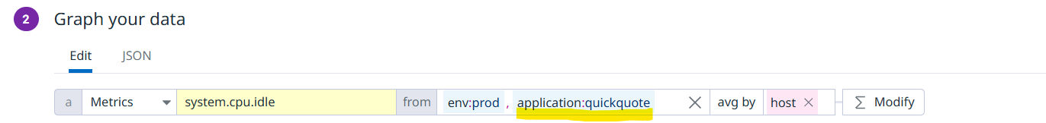

- If you’re nor aware of the application name or if the app name is not populating for these graphs, look for the exact app name tagged for your servers. Navigate to the Datadog URL - Host List | Datadog.

- Look for your servers under Search by and see if it populates as given below.

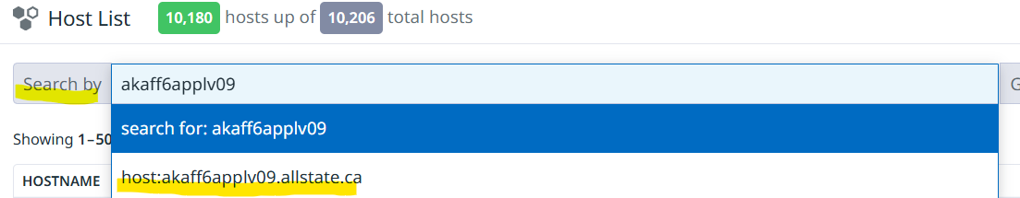

- Click on the Host and then look for Host Info (where you’ll see the exact application name and other tags mapped For instance: application, barometerit, service, env).

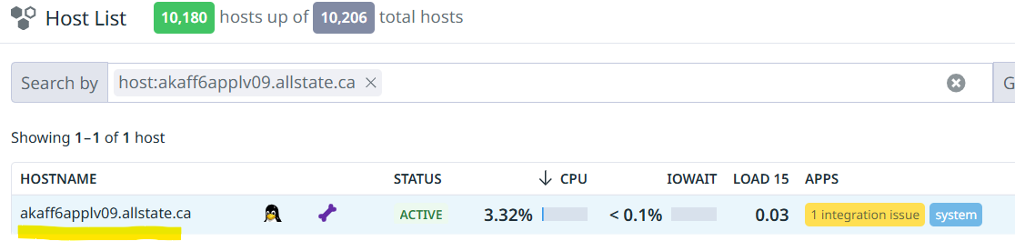

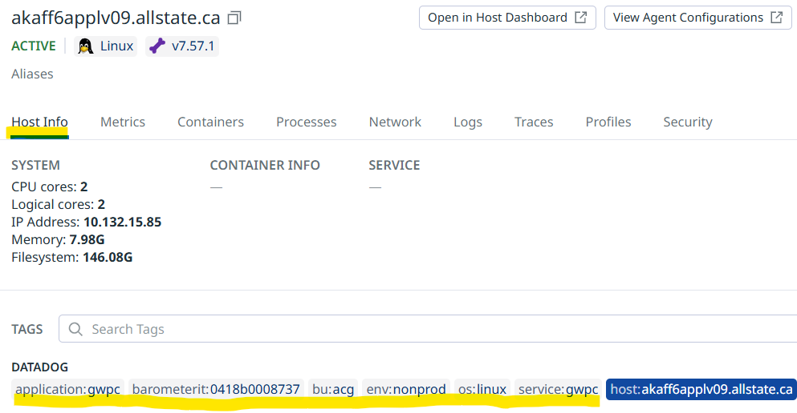

Note: If your servers are not populating, please put in place a request for the Monitoring Team for onboarding your product to the Datadog. Click Here

- Edit Service Status summary graph under Application Highlights and update the specific tags and widget title for your area/product and click on Save.

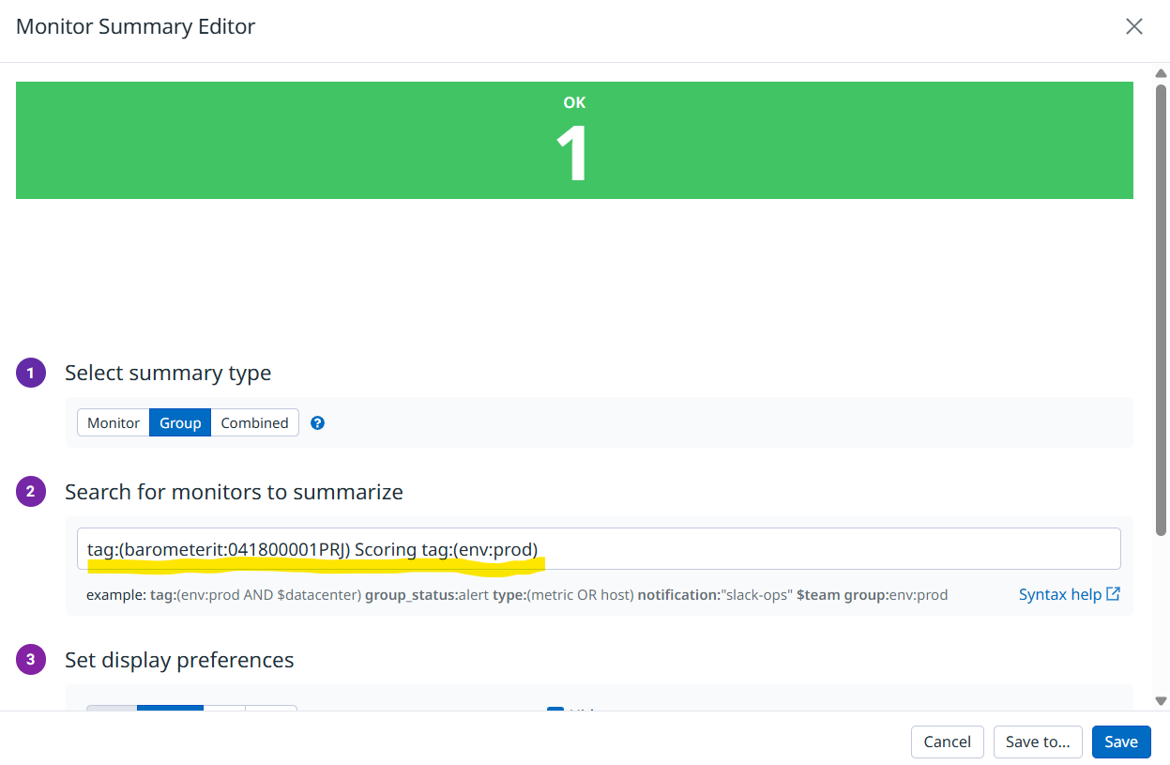
- Here Scoring is added as the name of the monitor to filter only the specific service. You can update this keyword as per your service/monitor names.

Note: If your service monitors are not populating, please put in place a request for the Monitoring Team for creating the same. Click Here

- To add similar widgets based on your product click on the widget icon highlighted below and click copy and paste it. Post that you can update the query parameters accordingly.

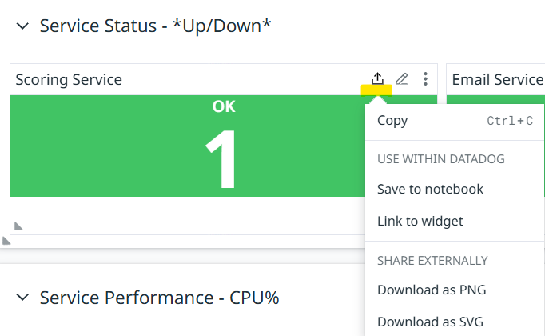

- If you’re not aware of the service/monitor name, please follow the below steps:
  - Navigate to the Datadog URL - Manage Monitors | Datadog
  - Update the highlighted value (i.e. Barometerit tag assigned to your servers. You can look for the tags defined in the above step) according to your product/app.
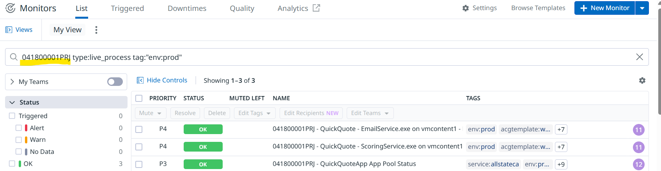
- Edit Service Performance - CPU% split graph and expand the Edit graph and replace the application tag specific to your product. If your product has more than 6 services, you can select the value from the dropdown as shown below.
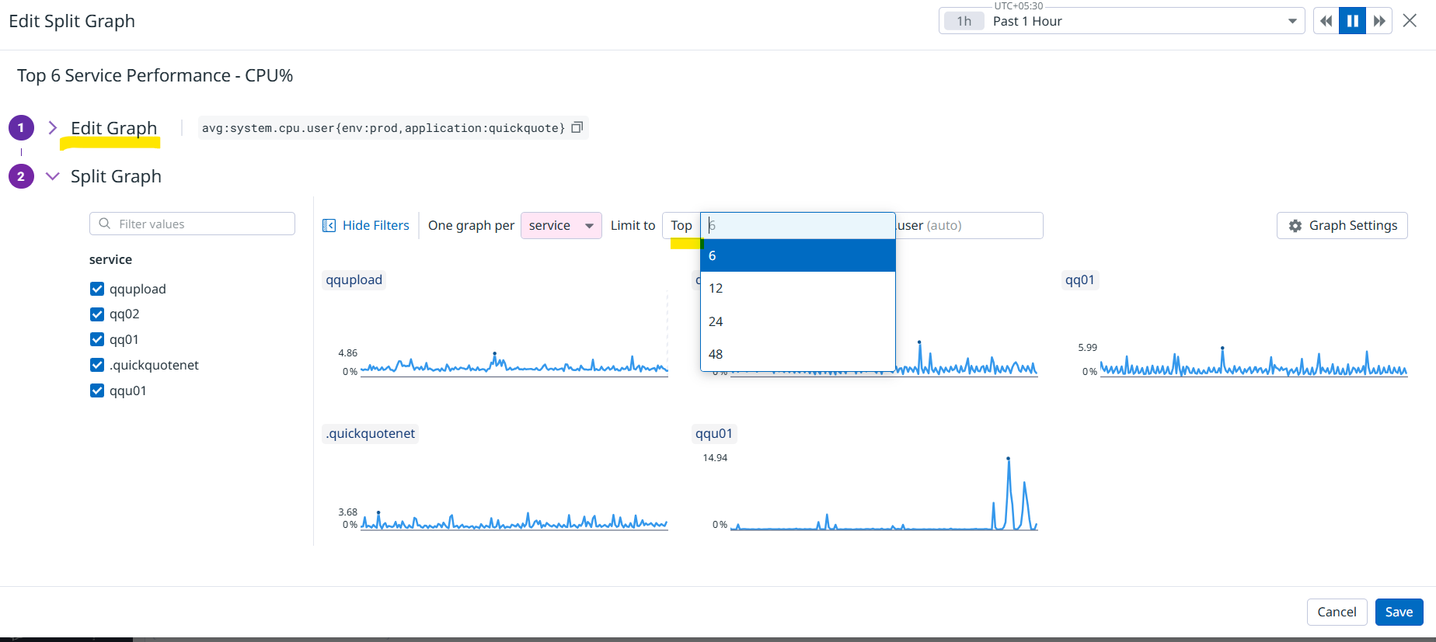

- Edit Memory & CPU Usage by QuickQuotePool widget and update the query filters and widget title as per your product. Here the command tag is populating based on your processes running on the servers. If there are multiple processes tagged with the same command (i.e. w3wp) you can add the specific process value (in this case “QuickQuotePool”).

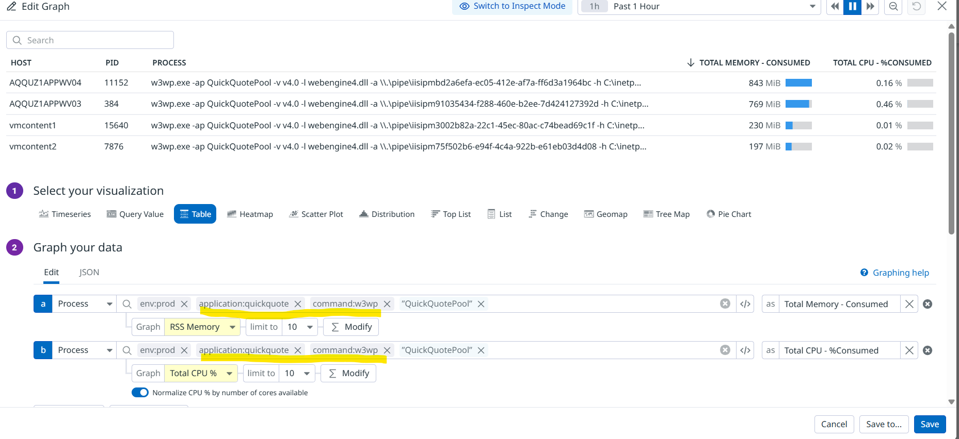
- If you’re not aware of the command tag of the process name running on the servers, please follow the below steps:
  - Navigate to the Datadog URL - Host List | Datadog.
  - Look for your servers under Search by and see if it populates as given below.

  - Click on the Host and then look for Processes tab to search for your process. For instance: kafka and click on it (kafka update query).
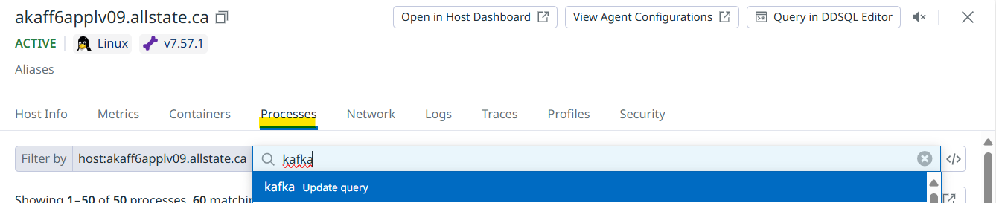

  - Click one of them from the below. The new window populates where the command name of the specific process is displayed.
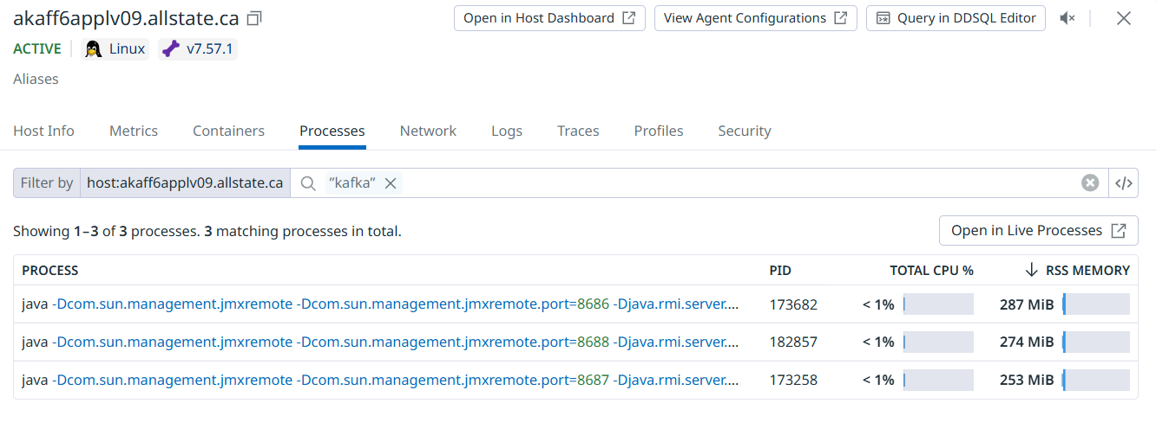

Command Name Screen:
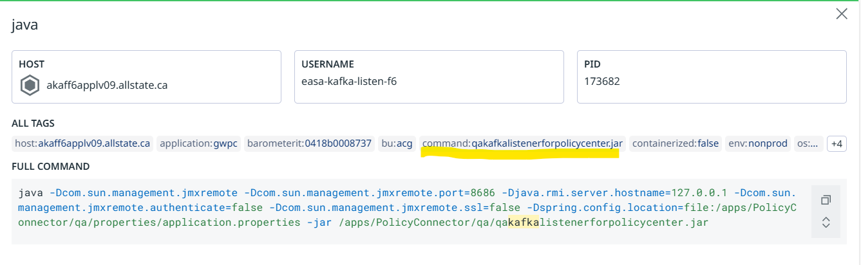

- Edit the CPU/Memory/Disk by Process Widgets and replace the application tag as per your product.

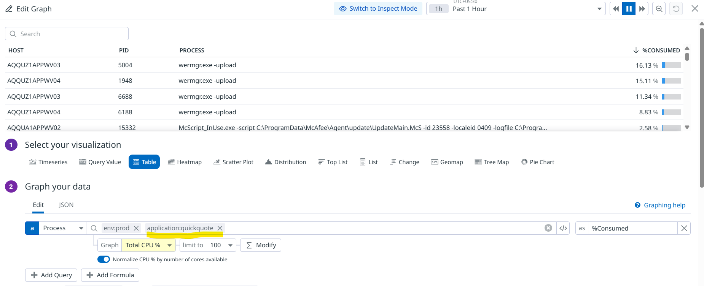

- Edit Service Flow widgets and select the application service from the service dropdown highlighted in the below and graph title as per your service.

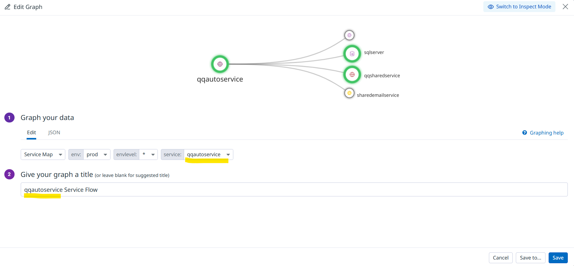

Note: If your service(s) are not populating, please put in place a request for the Monitoring Team for consultation or adding the app services. Click Here

- Edit Response Time Forecast By Service graph and update the application tag as per your product.

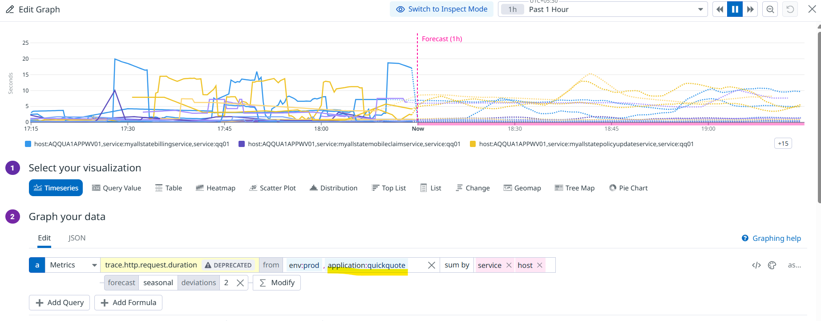

- Edit Error Count By Service graph and replace the application tag as per your product.

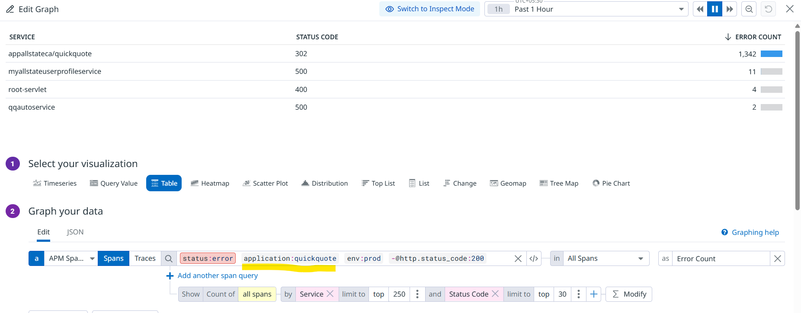

- Edit API Status graph and replace the barometerit tag value as per your product.

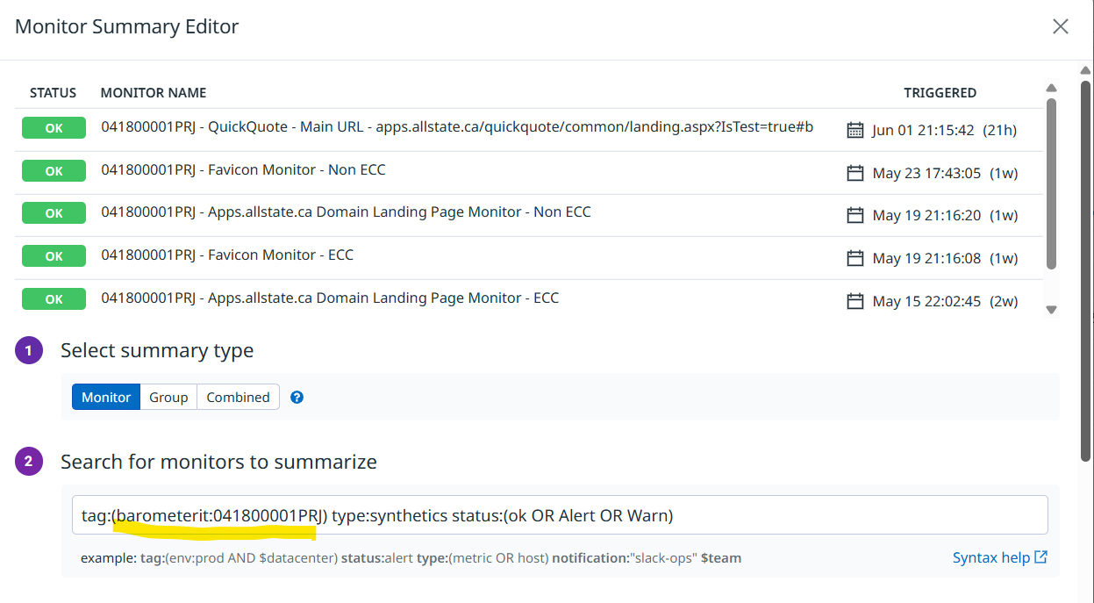

- Edit API Response Time API graph and replace the application tag value as per your product.

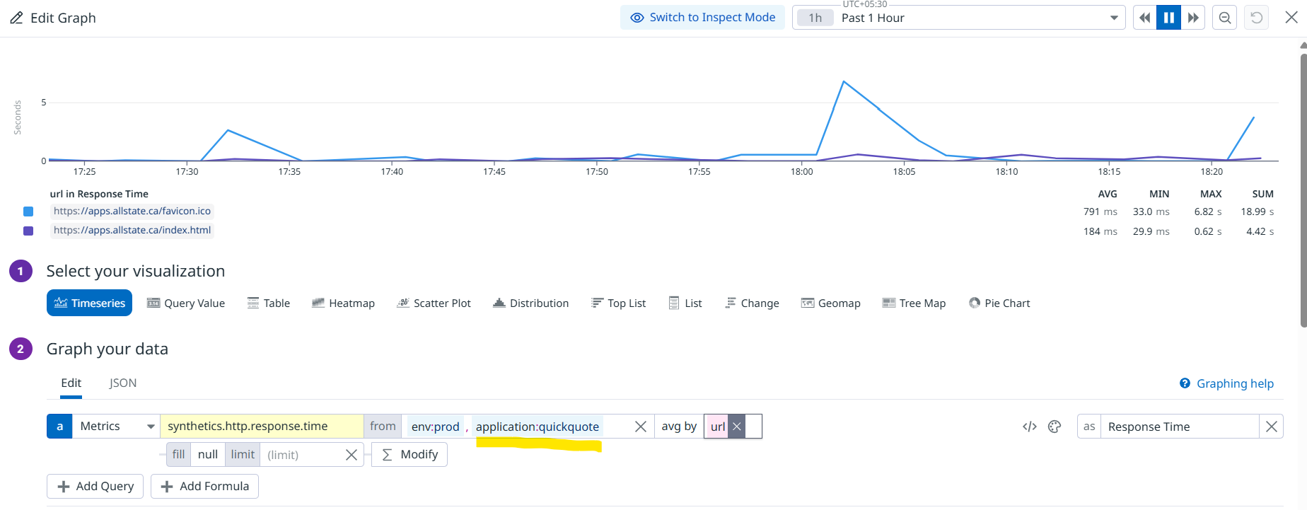

- Edit DB metric widgets and replace the database (only for DB status) and host value (for all DB widgets) highlighted as below based on your product/app and click Save.

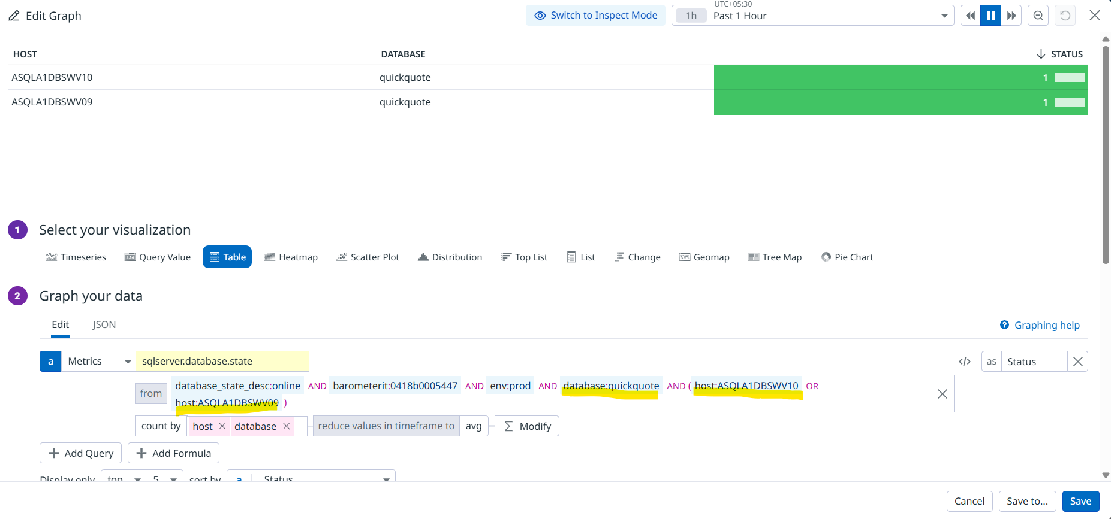
Note: If you’re not aware of the DB servers or DB names, please reach out to SQL DBAs DBAGroup@allstate.ca.

- Once you access the Database Dashboard, you can filter the DB servers as per your product/app then copy the address URL and replace the same under Database Dashboard widget and click Save as shown below.

